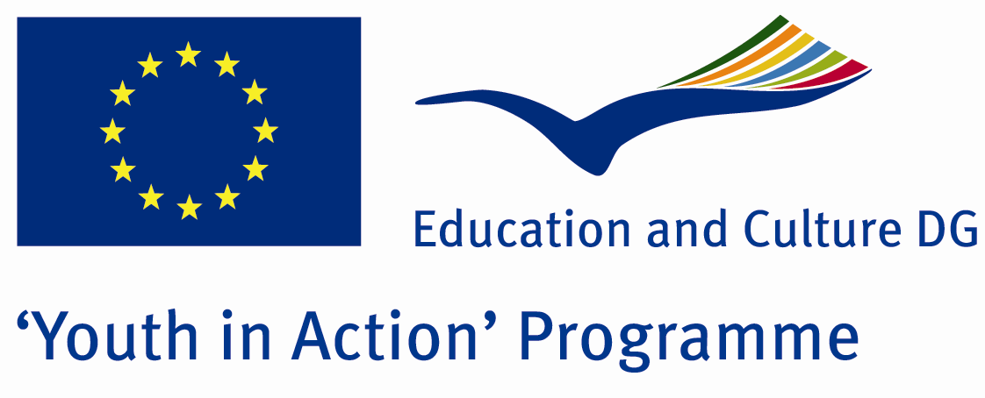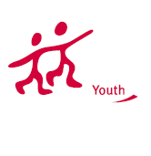

Action 1.1
Project Summary; What do you think about education equality? We want to show our country school system particularly and speak about which school what give the students… How can government make equality and democratic education in the schools? If you want to discussion about it, follow our Project!

Project Title; Democratic Education For Everybody
Date and Venue ; 05-12 2013 February Turkey
Place: Aydın

Target Group ; Municipalities, City Councils and Non-Governmental organizations,
youth groups,culture and art groups,e.t.c

Participants ; 5 people from each country (over 18 -25 ). Totally 7 countries.

Conditions ; Accommodation, board and programm costs will be financed through European Commission Youth in Action Programm . Travel costs will be reimbursed in 70% (APEX Tarrifs). Organizations from all 27 EU member countries plus Liechtenstein , Norway and Iceland are eligible to take part.

Working language: English

Organisator group: Youth Education Council

How to apply: If you are interested, please send your Part III forms to
by e-mail please (in word file). Scan Part3 format is enough for application.(Fulfilled Part III which you can find in the attachment, of course signed and stamped) ..

Contact e-mail: groupsymrnes@gmail.com
Group e-mail: educationcouncilaydin09@gmail.com

Deadline to apply:20.09.2012

